**CREATE A PROCEDURE**

**CREATE TABLE EMPLOYEE_DETAIL (EMP_ID INT PRIMARY KEY,EMP_NAME VARCHAR(20),SALARY INT);**

**INSERT INTO EMPLOYEE_DETAIL VALUES(1,'Abhilaash',30000);**

**INSERT INTO EMPLOYEE_DETAIL VALUES(2,'Balaji',32000);**

**INSERT INTO EMPLOYEE_DETAIL VALUES(3,'Deanjones',150000);**

**INSERT INTO EMPLOYEE_DETAIL VALUES(4,'harish',40000);**

**INSERT INTO EMPLOYEE_DETAIL VALUES(5,'Karthick',50000);**

SELECT *FROM EMPLOYEE_DETAIL ORDER BY EMP_ID;

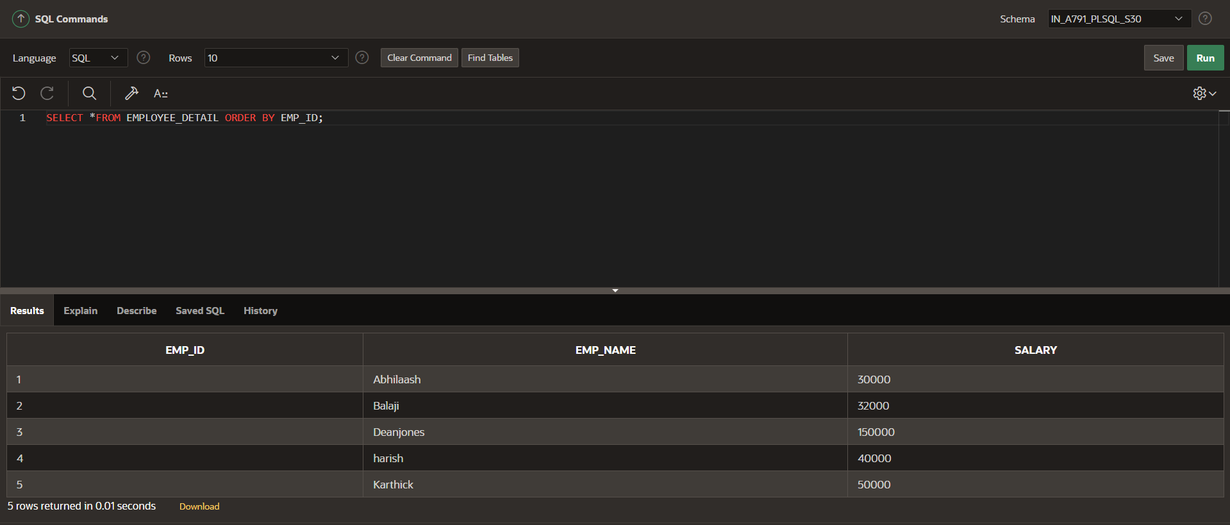

**PROCEDURE CREATION:**

CREATE OR REPLACE PROCEDURE EMP_DET IS

v_emp_id EMPLOYEE_DETAIL.EMP_ID%TYPE;

v_emp_name EMPLOYEE_DETAIL.EMP_NAME%TYPE;

v_salary EMPLOYEE_DETAIL.salary%TYPE;

BEGIN

v_emp_id:=6;

v_emp_name:='Suriya';

v_salary:=21000;

INSERT INTO EMPLOYEE_DETAIL VALUES(v_emp_id,v_emp_name,v_salary);

END;

**SELECT *FROM EMPLOYEE_DETAIL ORDER BY EMP_ID;**

